For Immediate Release

LORD CHOLMONDELEY HOSTS CASTLE RECEPTION
BACKING CHESTER VISUAL ARTS

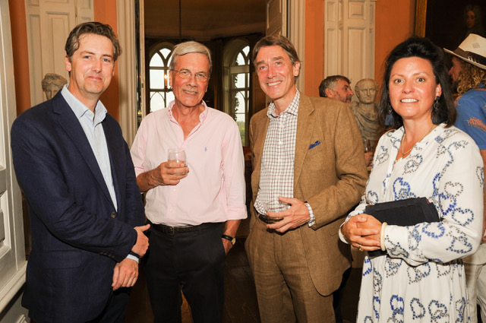

International art lover, Lord David Cholmondeley recently opened Cholmondeley Castle to
support local charity Chester Visual Arts and its mission to establish a permanent contemporary arts centre and gallery in Chester.

Over 100 prominent National and NW cultural leaders and “movers and shakers” attended the champagne reception at the castle, which aimed to raise awareness of the charity’s work in the region at a crucial moment in its development and to garner individual and corporate ‘Friends and Patrons’ in the coming months and years.

In his introduction, Lord Cholmondeley highlighted recent key successes, ‘“What Chester Visual Arts has accomplished in two years I think is extraordinary really with four major exhibitions, three with the V&A, and finding temporary accommodation in Chester. As well as the V&A in London, they’ve forged partnerships with the University of Chester, Chester Cathedral, Grosvenor Estate, the local Council and many others, and hats off to them for that. There are many other projects to come and finding a permanent space now in Chester is a priority.”

Ian Short, Chairman of Chester Visual Arts, emphasised that the organisation has now reached a “cliffhanger moment”, with incredible opportunities created and within reach, but ‘not yet enough resource, money or manpower to deliver’.

He went on “I’m really optimistic, however. We have our plans. Over the next year, we will begin to strengthen our resilience by recruiting an executive director and other professional support. We will create a master plan for the next three to five years.” He continued by outlining plans to identify medium-term space to develop its activities, including a rolling programme of local, national and international exhibitions, developing further strategic partnerships and the organisation’s education and outreach offer.

Notable attendees at the event included University of Chester Vice Chancellor, Tim Wheeler; Eddisbury MP Antoinette Sandbach; Dean of Chester Dr. Tim Stratford; and Nicholas Dobbs Rural Director, Grosvenor Estate.

Several internationally renowned Cheshire born artists and writers were present, including Richard Woods, Joe Crossley and Dan Fox, with local artists Matt Sherratt and Peter Beckett. Also present were Melanie Lenz, Curator V&A Museum, London; and Helen Legg, Director, Tate Liverpool.

For further information about Chester Visual Arts, and to find out how you can support the organisation, please visit: www.chestervisualarts.org.uk

ENDS

Image: Nicholas Dobbs, Grosvenor Estate; Ian Short, Chester Visual Arts; Lord Cholmondeley; Matilda Dobbs.

EDITOR’S NOTES

Chester Visual Arts
Chester Visual Arts is a registered charity (Registered charity no. 1180619) established to bring a new focus to visual arts provision to the City of Chester and the region. By bringing internationally acclaimed artists to the City of Chester and the wider region, CVA aims to establish a regular programme of quality events and exhibitions, which will lead to the City becoming a go to place nationally and internationally for the visual arts. Its ultimate aim is to create a permanent public art gallery in Chester. Two V&A touring exhibitions have previously been held in the Old Library: the Woman’s Hour Craft Prize and Pop Art in Print. The exhibition Our Colour Reflection by Liz West was held at Chester Cathedral. These exhibitions have attracted a total of over 40,000 local, national and international visitors, making a significant cultural contribution to the region.

CURRENT EXHIBITION

CHANCE AND CONTROL: ART IN THE AGE OF COMPUTERS
Address: The Old Library, Northgate Street, Chester, CH1 2EF
Until Sunday 8 September 2019
Opening times: Wednesday – Sunday, 11am – 5pm. Free admission.
The venue is fully accessible.

Created by the V&A – touring the nation.

Primary exhibition funder the Tyrer Charitable Trust.

Thanks to exhibition funders The Westminster Foundation, and supported using public funding by the National Lottery through Arts Council England.

For further information, including educational queries and press images, please contact Jack Welsh: jack@chestervisualarts.org.uk

